The Revolution is coming!
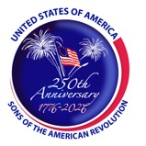
The Delaware Crossing Patriot
Kansas Society
Sons of the American Revolution
April 2026
Metro Kansas City’s Oldest & Largest Chapter, Founded 1960
Three Months- Four Days
NEXT MEETING:
When: April 18, 2026

Where: Milburn Country Club, 7501 W 69th St., Overland Park, KS 66204, 9:00am

Reservations & Cost: For reservations, email Secretary@dxsar.org or call Clay Shropshire 785-521-8122 by 7:00 PM, Tuesday, April 14, 2026.

Cost: $23.00/person

Program: Speaker – Topic

CALENDAR & COMING EVENTS

April 2026

15 DX EC Meeting
18 DX Chapter Meeting

May 2026

2 BOG
13 DX EC Meeting
26 DX Chapter Meeting

June 2026

17 DX EC Meeting
20 DX Chapter Meeting

The President’s Corner

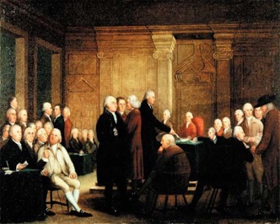

By Clay Shropshire

We are in the midst of the 250th anniversary of the American Revolution and the founding of the United States of America. It began in the morning on April 19, 1775, and ended with the Treaty of Paris on September 3, 1783.

We are descendants of those who sacrificed so that those who followed could live as free and independent citizens with the unalienable Rights of Life, Liberty, and the Pursuit of Happiness as endowed by their Creator.

It is up to each of us to work to preserve what our ancestors fought for, and some died for. Liberty and freedom are two precious commodities that can be taken for granted. Today we do not realize what we have. However, it can all be lost due to apathy and indifference and the pursuit of self-interest.

I look forward to this coming year and all of the possibilities it might bring to us as a Chapter of SAR and to the people of these United States.

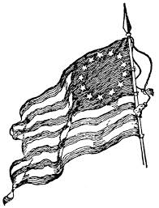

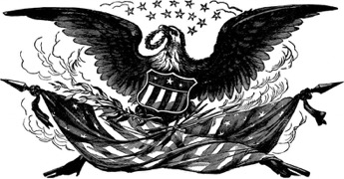

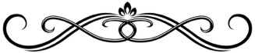

KSSSAR Annual Conference

Delaware Crossing was awarded sixteen streamers at the KS Annual Conference in Chanute on March 21. We received the following awards:
2025 KSSSAR Partners in Patriotism Award
2025 KSSSAR DAR Referral
2025 KSSSAR Attend 5 State Meetings
2025 KSSSAR Americanism
2025 KSSSAR USS Stark
2025 KSSSAR Liberty Bell
2025 KSSSAR Rumbaugh Oration Contest
2025 KSSSAR Youth Video
2025 KSSSAR JROTC & ROTC & Other Award
2025 KSSSAR Flag Certificate
2025 KSSSAR Flag Retirement Certificate
2025 KSSSAR Wreaths Across America
2025 KSSSAR Knight Essay Contest
2025 KSSSAR Patriotic Poster Contest
2025 KSSSAR Patriotic Brochure Contest
2025 KSSSAR Eagle Scout Contest

At our April Chapter Meeting, these streamers will be presented to the Color Guard Commander, Steven French, to hang proudly on our streamer pole.

March Chapter Meeting in Review

Our Chapter Meeting was led by Larry Tatum, and the program was our annual Chapter Awards. Larry presented the following awards to compatriots for their work over the past year and beyond:
The Bronze Oak Leaf Cluster for the Henry Knox Medal to Compatriot David Pierson for sponsoring 100 wreaths in Wreaths Across America through our Chapter. I will deliver this award and certificate to Compatriot Pierson.
The Bronze Roger Sherman Medal to Compatriot Gary Kicks for serving as Sargent-at-Arms
The Bronze Oak Leaf Cluster for Roger Sherman Medal to Compatriot Daniel Dryer for serving as Chairman of the JROTC Committee (first oak leaf cluster)
The Bronze Oak Leaf Cluster to Compatriot Bruce Smith for serving as Chapter Chaplain, Essay Contest, Brochure Contest, Video Contest, GWBC Committee Representative, and being a Color Guardsman (first oak leaf cluster)
The Bronze Meritorious Service Medal to Compatriot Rick Alley for serving as Chapter Web Master over the past 5 years and occasionally Acting Chaplain
The Bronze Meritorious Service Medal to Compatriot Kevin Dyches for serving as Treasurer for the past two years
The Bronze Meritorious Service Medal to Compatriot Ken Ludwig for serving as Board Member of the Kesler Youth Endowment Fund, as Chapter Auditor, and as Chapter Representative in the KSSSAR BOG Meetings
The Bronze Meritorious Service Medal to Compatriot Clay Shropshire for serving as Chapter Secretary for the past two years as Executive VP for the past year, and for being a Color Guardsman
The Bronze Oak Leaf Cluster for Chapter Meritorious Service Medal to Compatriot Steven French for serving as Chapter Color Guard Commander and Chairman of the Fire Safety Award, the Law Enforcement Award, and EMS Committees
The Bronze Oak Leaf Cluster for Chapter Meritorious Service Medal to Compatriot Dewey Fry for serving as Chairman of the Medals and Awards, Flag Display & Retirement, Elementary School Poster Contest, Veterans Services, D.A.R. Liaison, Wreaths Across America Committees and for being Mentor
The Bronze Oak Leaf Cluster for Chapter Meritorious Service Medal to Compatriot Dennis Nelson for serving as Americanism Committee Chair and providing the Milestone in Revolutionary War History at each chapter meeting
The Bronze Oak Leaf Cluster for Chapter Meritorious Service Medal to Compatriot Timothy Peterman for serving as Chapter Registrar and Genealogist
The Bronze Oak Leaf Cluster for Chapter Meritorious Service Medal to Compatriot Kirk Rush for serving as the Chapter Eagle Scout Committee Chair

After the gavel was passed from Larry Tatum to Clay Shropshire, the new President awarded Larry Tatum the Bronze Meritorious Service Medal for serving as President 2 times and for serving as Newsletter Editor for the past seven years.

Since Dewey Fry is recovering from hip surgery, there are no pictures available at this time. I will try to create an addendum to this newsletter to add them later.

We wish Dewey a speedy recovery and we understand if he has little to no interest in marching in parades. We need vehicle drivers also to pull the trailer with older compatriots and Color Guardsmen.

Your Color Guard at Work

There was a Naturalization at Johnson County Community College Auditorium on March 18. There was a fairly small group of new citizens as opposed to other Naturalizations conducted at the College.

On March 27 several members assisted in welcoming veterans arriving home from an Honor Flight hosted by Southern Coffey County High School.

On March 28 there were two events going on simultaneously. The first event was held at the Johnson County Research Library in Overland Park presenting a Research Symposium hosted by the Johnson County Genealogical Society. A team led by Dennis Nelson displayed some Patriot Chest items and had several gentlemen sign our registration form with contact information.

Later that morning several DAR Chapters held a Kid’s Fair at the Johnson County Museum in Overland Park. Another team of compatriots displayed Patriot Chest games and items of interest to the younger set. It was fun to watch as kids and parents would try to get the ball to land in the cup. Some would try a couple of times and then hand the game to another to try their luck. Others were determined to get the task accomplished no matter how long it took.

Again, Pat Fry takes the pictures at events while Dewey and others are busy being Color Guardsmen.

New Compatriots Serving You

The Chapter will have a new Secretary after approval by the membership at the April meeting. Compatriot Dr. Tom Black has agreed to step forward and assist with this very important position for Delaware Crossing.

Compatriot Dave Yuengert accepted an appointment as Chapter Chaplain.

Compatriot Clay Shropshire has accepted an appointment as Web Master. It will be interesting to see how long it goes before something is really messed up and he has to call Rick Alley for assistance.

Other compatriots have expressed interest in assisting with some committee assignments and those will be published as soon as details have been worked out.

We are still in need of an Executive VP and a Newsletter Editor, just to name a few. We will need to discuss the September Picnic since Dewey and Pat Fry have stated they need to step away from heading up this event.

